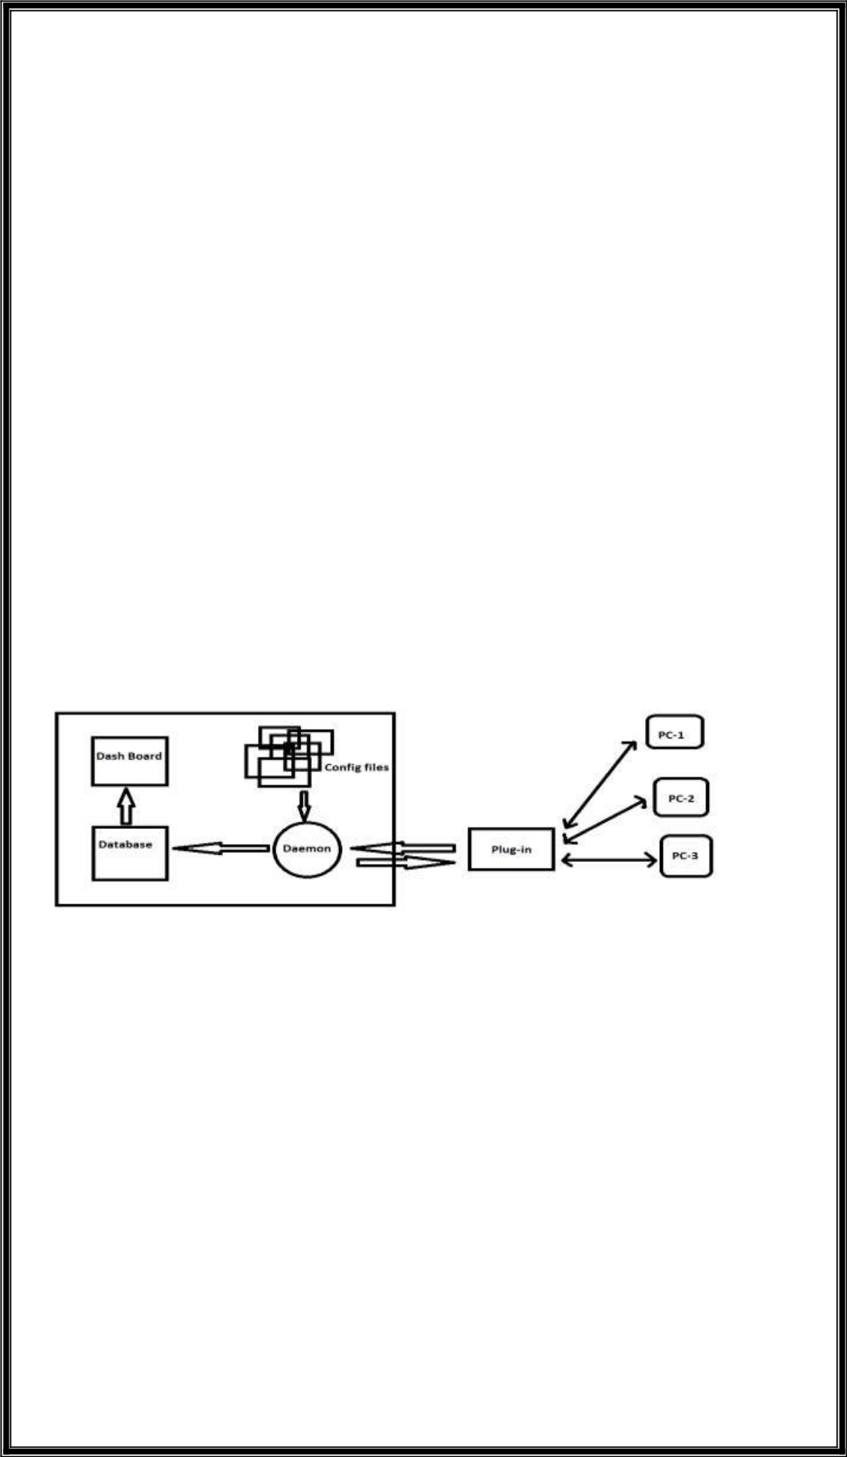**NAGIOS**

* Nagios is a Monitoring tool.
* We need to write scripts to monitor.
* Nagios is a complex tool to use. For installation itself we should run “n” number of commands.

---------> Why we need monitoring tool?

* High Availability (servers should be always append running)
* Reduce downtime (if servers goes down we should fix asap)

----------> We can monitor by using:

* Scripts
* Tools

----------> Why Nagios?

* Oldest & Latest.
* Stable.
* So many Plug-ins (configuration files)
* Own Database (Nagios server will collect data from other machines and save it to its own database )
* For both Monitoring & Alerting.

-----------> Architecture of Nagios.

* configuration files: we will write scripts like machine details(like machines IP address,username,PW or key),metrics,time intervals and threshold level.we can also call this as Plugins.
* Daemon : back-end server that always in running state and read information from config. Files. And inform to the Plug-in(NRPE)
* Plug-in : This NRPE (Nagios Remote Plugin Executor) go to Nodes through “ssh” and in nodes also we will install nagios related thing that will install “checkbyssh” plugin.then this NRPE goes to checkbyssh and get the data of that particular node from checkbyssh and this data will be given to Daemon. Then this daemon will store in its own database.
* Database : stores data of every node and displays in Dashboard.
* Dashboard : shows the data of nodes from database.

-------> How does it works.

* Mention all details in config files
* Daemon read those details what data to be collected
* Daemon use NRPE plug-in to collect data form nodes and stores in its own database
* Finally displays in dashboard

--------> Important to note

* Plug-ins
  + Can use open source (Community plug-ins)
  + Can write your own

--------> To Install Nagios Pre-requisites are:

* httpd (we access through Browser)
* php (dashboard)
* GCC & GD (compilers) (To convert raw code into binaries)
* makefile (to build)
* perl (script)

-------> Main configuration file

* /usr/local/nagios/etc/nagios.cfg
* All monitoring things called as "Services". Eg: 5 servers - 3 checks each

You have to monitor 5*3 = 15 services.

* While define plug-ins, we set Upper & Lower limit of monitoring range(like <90 or >90….).
* Things to mention for each server in config files
  + Username & Password
  + Service
  + IP address
  + Upper & Lower threshold

---------> Dashboard overview

➢In dashboard, you can see Hosts --> down (server down)

|  |  |  |  |  |
| --- | --- | --- | --- | --- |
|  |  |  | Unreachable (network issue) |  |
|  |  |  | Recovery (under progress) |  |
|  |  |  | none (no information) |  |
| ➢ |  | ---> | warning (alarm) |  |
| Services |  |
|  |  |  | Unknown (don’t know to Nagios) |  |
|  |  |  | Critical (final alarm) |  |
|  |  |  | Recovery (under progress) |  |

---------> To monitor remote machines.

* Install NRPE (Nagios Remote Plug-in Executor) on server
* Use check-by-ssh plugin (this plugin has to be in remote machines)
* libexec folder(where plugins will be stored)
* NRPE plugin in nagios server will go to client by ssh & invoke check-by-ssh plugin.
* Grouping(we can group server(nodes) based on their work)
  + Servers(Host group like webservers,database sever…..)
  + Services(Service group like CPU,RAM…..)

----------> Nagios Installation.

* Launch one new instance with HTTP ports open.
* Installing dependencies.
* yum install -y httpd httpd-tools php gcc glibc glibc-common gd gd- devel make 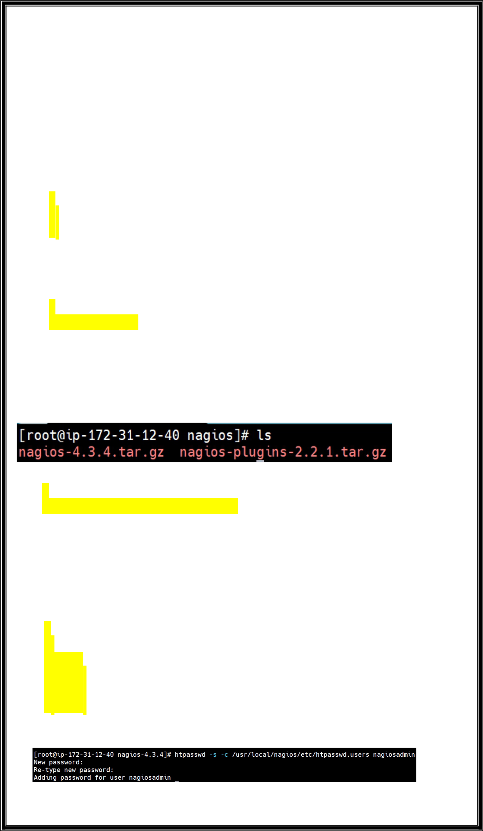net-snmp

➢Creating Nagios user and creating a group,adding user to group.

* + useradd nagios
  + groupadd nagcmd
  + usermod -G nagcmd nagios
* Adding user to apache group because after installing apache we will get default group.
  + usermod -G nagcmd apache
* Creating directory and going inside that directory.
  + mkdir /root/nagios
  + cd /root/nagios
* Downloading nagios tar and zip package.

# wget https://assets.nagios.com/downloads/nagioscore/releases/nagios-4.3.4.tar.gz

* Downloading Plugins package.
  + - * wget https://nagios-plugins.org/download/nagios-plugins-2.2.1.tar.gz
* If we do ls we can see this both packages.
* Now we are going to extracting this both files.
  + tar -xvf nagios-4.3.4.tar.gz
  + tar -xvf nagios-plugins-2.2.1.tar.gz
* To see do
  + ls -l
* Go inside the directory.
  + cd nagios-4.3.4/
* Now modify configure file.
  + - ./configure --with-command-group=nagcmd
* Installing some required plugins.
  + - make all
    - make install
    - make install-init
    - make install-commandmode
    - make install-config
    - make install-webconf
* Now setting password.
  + htpasswd -s -c /usr/local/nagios/etc/htpasswd.users nagiosadmin
* 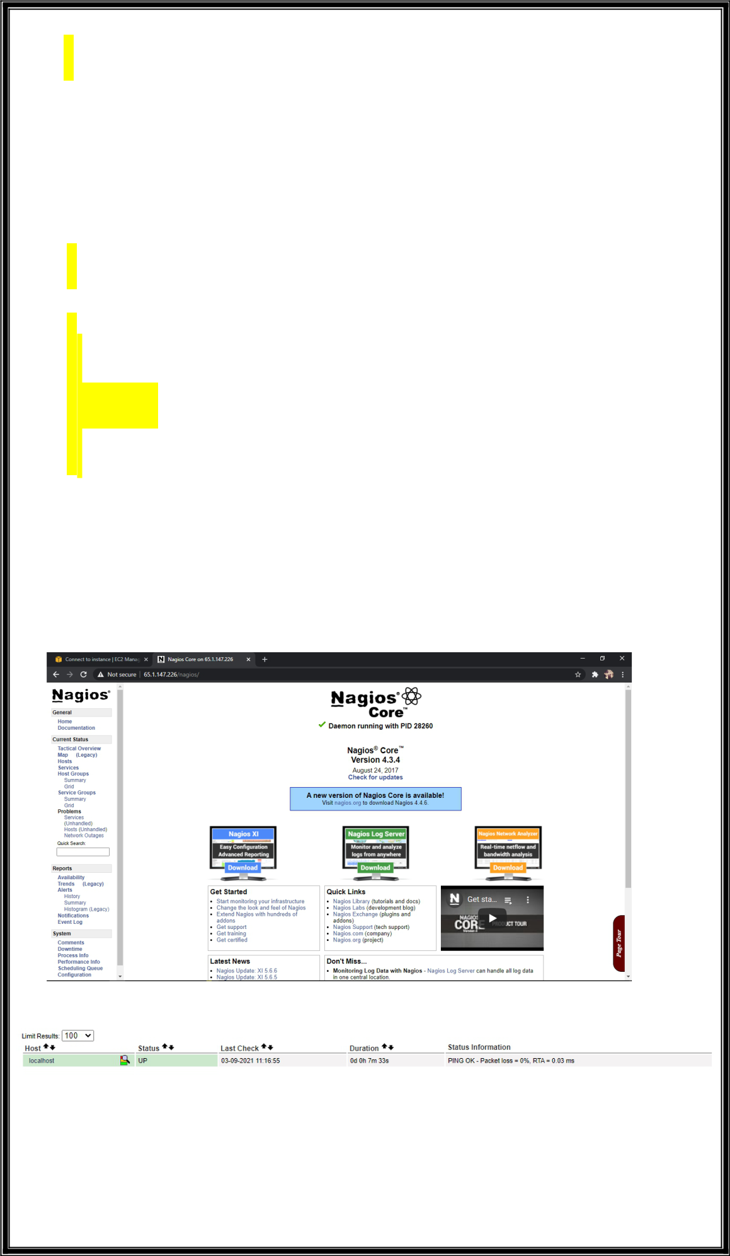Starting server and enable service.
  + service httpd start
  + systemctl start httpd.service
* Now go to nagios directory.
  + cd /root/nagios
    - * cd nagios-plugins-2.2.1/
* Changing some configuration.
  + ./configure --with-nagios-user=nagios --with-nagios-group=nagios
* Again installing some plugins
  + make
    - make install
    - /usr/local/nagios/bin/nagios -v /usr/local/nagios/etc/nagios.cfg
* Now running some chkconfig commands and starting service.
  + - chkconfig --add nagios
    - chkconfig --level 35 nagios on
    - chkconfig --add httpd(here we may get error just proceed to next step)
    - systemctl enable nagios
    - systemctl enable httpd
    - service nagios start
    - systemctl start nagios.service

--------> Accessing Nagios.

* To access Nagios we need to take “Instance’s Public IP/nagios” and paste it in

browser.

➢Then Username = nagiosadmin

Password = <what we have given during installation>

* As and then we enter nagios, the page will be like this.
* Here on left side -> Hosts(click that) there we can find our local machine is monitoring because by default nagios will monitor local machine(ec2 instance).



